Module 8 Lab – VTI VPN
Topology
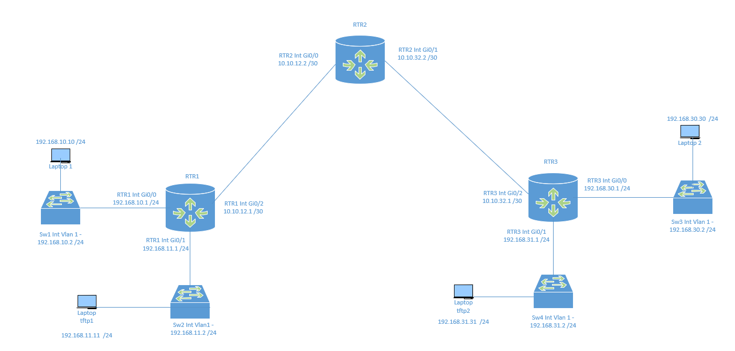

IP Addressing Table
Device | Interface | IP Address | Subnet Mask | Default Gateway | Switch Port
R1 | G0/0 | 192.168.10.1 | 255.255.255.0 | N/A | Port 1
 | G0/1 | 192.168.11.1 | 255.255.255.0 | N/A | Port1
 | G0/2 | 10.10.12.1 | 255.255.255.252 | N/A | N/A
R2 | G0/0 | 10.10.12.2 | 255.255.255.252 | N/A | N/A
 | G0/1 | 10.10.32.2 | 255.255.255.252 | N/A | N/A
R3 | G0/0 | 192.168.30.1 | 255.255.255.0 | N/A | Port 1
 | G0/1 | 192.168.31.1 | 255.255.255.0 | N/A | Port 1
 | G0/2 | 10.10.32.1 | 255.255.255.252 | N/A | N/A
Laptop1 | NIC | 192.168.10.10 | 255.255.255.0 | 192.168.10.1 | Port 2
SW1 | Vlan1 | 192.168.10.2 | 255.255.255.0 | 192.168.10.1 | N/A
TFTP1 | NIC | 192.168.11.11 | 255.255.255.0 | 192.168.11.1 | Port 2
SW2 | Vlan1 | 192.168.11.2 | 255.255.255.0 | 192.168.11.1 | N/A
Laptop2 | NIC | 192.168.30.30 | 255.255.255.0 | 192.168.30.1 | Port 2
SW3 | Vlan1 | 192.168.30.2 | 255.255.255.0 | 192.168.30.1 | N/A
TFTP1 | NIC | 192.168.31.31 | 255.255.255.0 | 192.168.31.1 | Port 2
SW2 | Vlan1 | 192.168.31.2 | 255.255.255.0 | 192.168.31.1 | N/A

Objectives
To set up a Virtual Tunnel Interface (VTI) between R1 and R3 on Cisco 2911 routers, you can follow these configuration steps. We'll define the necessary configurations on each router, including the tunnel interfaces, IPsec policy, ISAKMP settings, and traffic shaping. Finally, I'll include some verification commands to test the tunnel.
Background / Scenario
VPNs can provide a secure method of transmitting data over a public network, such as the Internet. VPN connections can help reduce the costs associated with leased lines. Site-to-Site VPNs typically provide a secure (IPsec or other) tunnel between a branch office and a central office. Another common implementation of VPN technology is remote access to a corporate office from a telecommuter location, such as a small office or home office.
In this lab, you will build and configure a multi-router network, use Cisco IOS to configure a VTI VPN, and then test the VPN. The VTI VPN tunnel is from R1 to R3 via R2. R2 acts as a pass-through and has no knowledge of the VPN. IPsec provides secure transmission of sensitive information over unprotected networks, such as the Internet. IPsec acts at the network layer and is protecting and authenticating IP packets between participating IPsec devices (peers).
Required Resources
- 3 routers (Cisco 1941 with Cisco IOS Release 15.4(3)M2 image with a Security Technology Package license)
- 2-4 switches (Cisco 2960 or comparable)
- 2-4 PCs
- Ethernet cables, as shown in the topology and console cables to configure Cisco networking devices.

- Configure Basic Device Settings
In Part 1, you will set up the network topology and configure basic settings, such as the interface IP addresses, dynamic routing, device access, and passwords.
Note: All tasks should be performed on R1, R2, and R3. The procedure for R1 is shown here as an example.
    - Cable the network as shown in the topology.
Attach the devices as shown in the topology diagram and cable as necessary.
    - Configure basic settings for each router.
      - Configure hostnames, as shown in the topology.
      - Configure the interface IP addresses, as shown in the IP Addressing Table.
    - Disable DNS lookup.
Disable DNS lookup to prevent the router from attempting to translate incorrectly entered commands.
Conf t
No ip domain-lookup
    - Configure the OSPF routing protocol on R1, R2, and R3.
      - On R1, use the following commands:
R1(config)# router ospf 5
R1(config-router)# network 192.168.10.0 0.0.0.255 area 5
R1(config-router)# network 192.168.11.0 0.0.0.255 area 5
R1(config-router)# network 10.10.12.0 0.0.0.3 area 5
      - On R2, use the following commands:
R2(config)# router ospf 5
R2(config-router)# network 10.10.12.0 0.0.0.3 area 5
R2(config-router)# network 10.10.32.0 0.0.0.3 area 5
      - On R3, use the following commands:
R3(config)# router ospf 101
R3(config-router)# network 192.168.30.0 0.0.0.255 area 5
R3(config-router)# network 192.168.31.0 0.0.0.255 area 5
R3(config-router)# network 10.10.32.0 0.0.0.3 area 5

    - Configure PC host IP settings.
      - Configure a static IP address, subnet mask, and default gateway for Laptop1, as shown in the IP Addressing Table.
      - Configure a static IP address, subnet mask, and default gateway for TFTP1, as shown in the IP Addressing Table.
      - Configure a static IP address, subnet mask, and default gateway for Laptop2, as shown in the IP Addressing Table.
      - Configure a static IP address, subnet mask, and default gateway for TFTP2, as shown in the IP Addressing Table.
    - Confiigure the Switch Vlan 1 ip addresses.
      - Configure a static IP address, subnet mask, and default gateway for SW1 and SW2, as shown in the IP Addressing Table. Remember that it is int Vlan1 that you are configuring.
      - Configure a static IP address, subnet mask, and default gateway for SW3 and SW4, as shown in the IP Addressing Table. Remember that it is int Vlan1 that you are configuring.
    - Verify basic network connectivity.
      - Ping from R1 to the R3 G0/1 interface at IP address 192.168.33.1.
If the pings are unsuccessful, troubleshoot the basic device configurations before continuing.
      - Ping from Laptop1 and TFTP1 to Laptop2 and TFTP2 .
If the pings are unsuccessful, troubleshoot the basic device configurations before continuing.
Note: If you can ping from Laptop1 to Laptop2 (and between the tftp laptops), you have demonstrated that the OSPF routing protocol is configured and functioning correctly. If you cannot ping, but the device interfaces are up and IP addresses are correct, use the show run and show ip route commands to help identify routing protocol-related problems.
    - Configure passwords so that you can telnet (this might make it easier for you to troubleshoot)
Configure the same settings for R1 and R3. R1 is shown here as an example.

Conf t
Enable secret Pass-12345
Line vty 0 4
Password Pass-12345
Transport input all

- Configure a Site-to-Site VPN with Cisco IOS
In Part 2 of this lab, you will configure an VTI VPN tunnel between R1 and R3 that passes through R2. . You will then review and test the resulting configuration.
Before you beginTask1:
- If you are configuring Router1:
- Traceroute from Sw1 and SW2 to Sw3 and Sw4,
- Record the hops here for one of the traceroutes (there should be three or four entries).
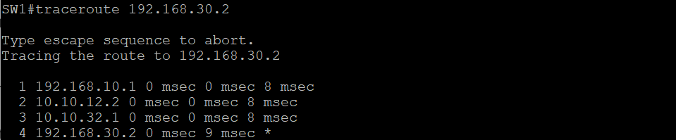
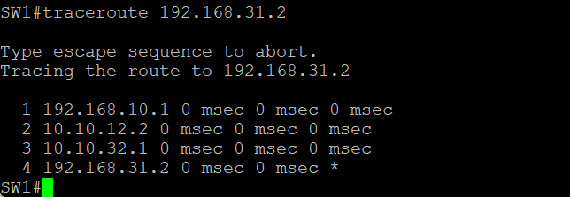

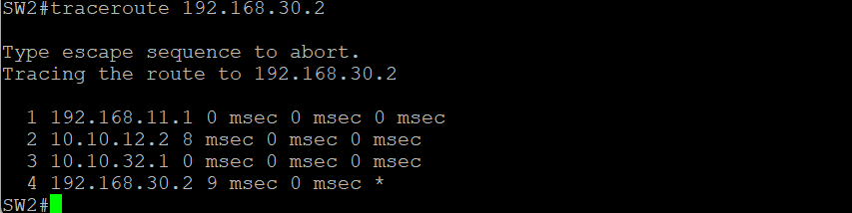
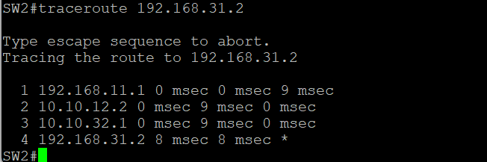

- If you are configuring Router2:
- Traceroute from Sw3 and SW4 to Sw1 and Sw2,
- Record the hops here for one of the traceroutes (there should be three or four entries).
____________________________________

You will now configure an IPSEC VTI and compare those tracertouet later
  - Configure IPsec VPN Settings on R1 and R3.
    - Configure the routers with the following information:
R1 Configuration:
! Define the policy map
policy-map FOO
class class-default
shape average 128000

! ISAKMP policy
crypto isakmp policy 1
encr 3des
authentication pre-share
group 14
crypto isakmp key cisco123 address 0.0.0.0 0.0.0.0
crypto isakmp keepalive 10

! IPsec transform set and profile
crypto ipsec transform-set TSET esp-3des esp-sha-hmac
crypto ipsec profile VTI
set transform-set TSET

! Tunnel interface configuration
interface Tunnel0
ip address 192.168.55.1 255.255.255.0
tunnel source 10.10.12.1
tunnel destination 10.10.32.1
tunnel mode ipsec ipv4
tunnel protection ipsec profile VTI
service-policy output FOO

R3 Configuration:
! Define the policy map
policy-map FOO
class class-default
shape average 128000

! ISAKMP policy
crypto isakmp policy 1
encr 3des
authentication pre-share
group 14
crypto isakmp key cisco123 address 0.0.0.0 0.0.0.0
crypto isakmp keepalive 10

! IPsec transform set and profile
crypto ipsec transform-set TSET esp-3des esp-sha-hmac
crypto ipsec profile VTI
set transform-set TSET

! Tunnel interface configuration
interface Tunnel0
ip address 192.168.55.2 255.255.255.0
tunnel source 10.10.32.1
tunnel destination 10.10.12.1
tunnel mode ipsec ipv4
tunnel protection ipsec profile VTI
service-policy output FOO

Verification Commands

At this point, you should have an IPsec VTI tunnel setup. Before we move on to the testing phase we are going to tweak the routing table on the routers. Please run the following commands:

On RTR1: ip route 192.168.31.0 255.255.255.0 192.168.55.2
On RTR3: ip route 192.168.10.0 255.255.255.0 192.168.55.1

After configuring both routers, use the following commands to verify the tunnel’s status and connectivity: Paste your output after each command:

- Check the tunnel interface status:
show interface Tunnel0

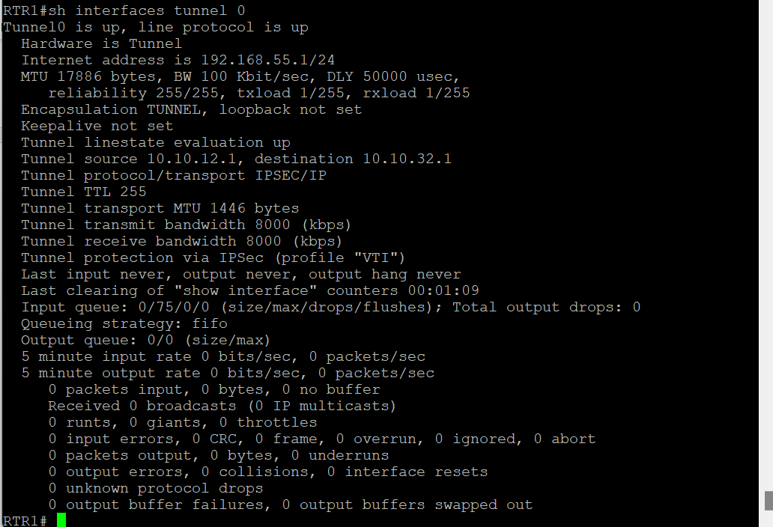

- Verify IPsec Security Associations (SA):
show crypto ipsec sa
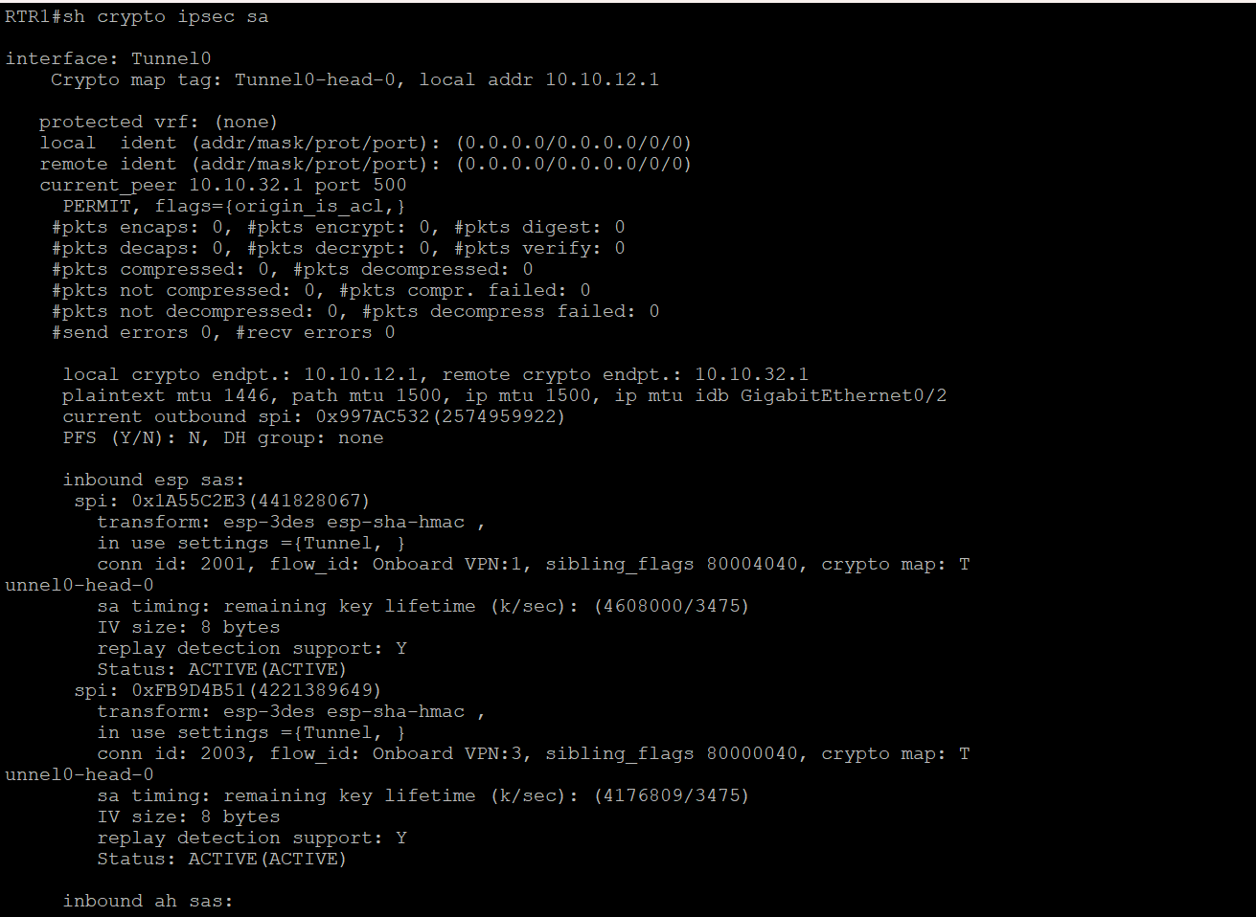
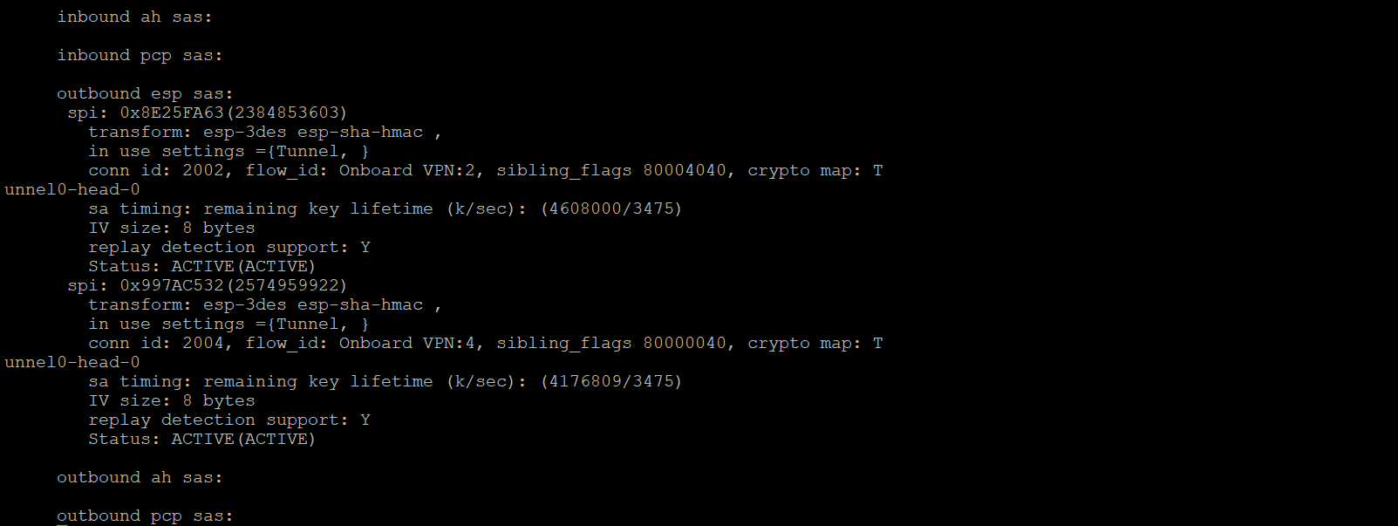
- Verify ISAKMP Security Associations:
show crypto isakmp sa
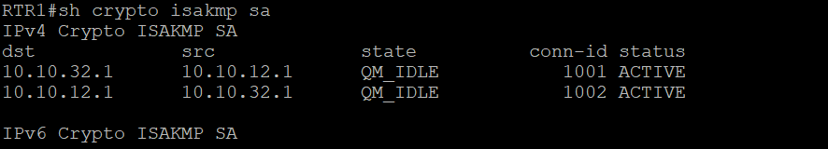

- Test connectivity across the tunnel:
- For the person configuring RTR1: From Sw1 traceroute to SW4’s IP address, paste the results below:
Traceroute 192.168.31.2
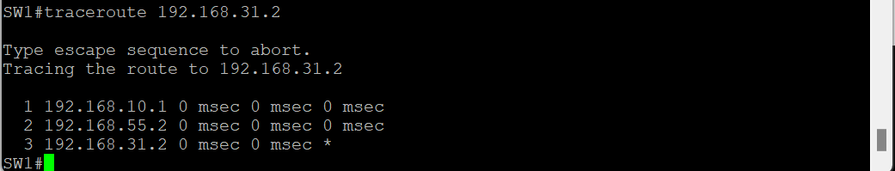

- For the person configuring RTR1: From Sw2 traceroute to SW3’s IP address, paste the results below:
Traceroute 192.168.30.2
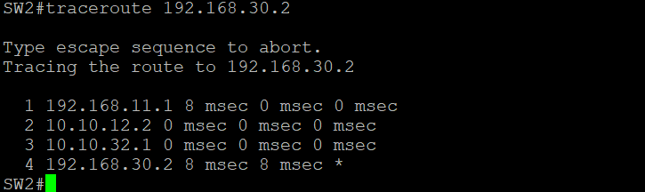
- For the person configuring RTR2: From Sw3 traceroute to SW2’s IP address, paste the results below:
Traceroute 192.168.11.2
- For the person configuring RTR2: From Sw4 traceroute to SW1’s IP address, paste the results below:
Traceroute 192.168.10.2

Each person: explain the difference between the outputs of your two traceroutes.
The route from SW1 is going through the tunnel to get to SW4 because it was added to the routing table on RTR1.
The route from SW2 to SW3 is not going through the tunnel since there is no entry for that in the routing table.

- Verify the application of the policy map:
show policy-map interface Tunnel0
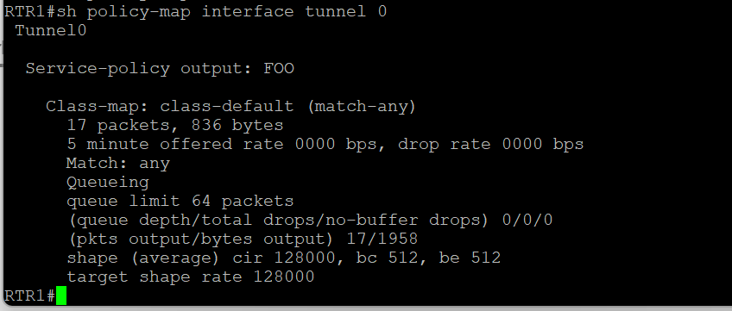

Notes
- Ensure that both routers have IP reachability to each other's tunnel source addresses (10.10.12.1 for R1 and 10.10.32.1 for R3).
- Adjust any firewall settings to allow IPsec traffic (ESP and ISAKMP) between these IPs.
- The crypto isakmp key command should include a shared secret that is identical on both routers for authentication.
This setup and verification should establish a secure IPsec tunnel between R1 and R3, using the Virtual Tunnel Interface with the IP addresses specified. Let me know if you have questions on any specific part of the configuration!

Reflection
  - Would traffic on the Gigabit Ethernet link between PC-A and the R1 G0/0 interface be encrypted by the site-to-site IPsec VPN tunnel? Explain.
No, because that path is not part of the tunnel.
  - What is the purpose of that Policy map configuration? Why would you think that we should ever use it?
Policy map is a powerful tool that could be applied for encryption. For example, it would be used an algorithm to encrypt the messages going through the tunnel. Both sides could have a pre-shared key and would know how to decrypt the messages.

